TITLE: IRON DEFICIENCY ANEMIA
Subtitle: Diagnosis of iron deficiency anemia in pregnancy
SUMMARY: The Centers for Disease Control and Prevention recommends screening for iron deficiency anemia (IDA) in pregnant people. A failure to maintain sufficient levels of iron may result in adverse maternal–fetal consequences including postpartum depression, low birth weight, preterm delivery, and perinatal mortality.
Rationale: The most common cause of anemia in pregnancy is iron deficiency. IDA has a prevalence of 18-35 per 1000 women, with higher rates in non-Hispanic black gestational parents and teens. IDA rates increase throughout pregnancy and may exceed 25% in the third trimester in some populations. Perinatal iron supplementation is important because the typical American diet and endogenous stores are insufficient sources for the steadily increasing iron requirements of pregnancy. The spectrum of iron deficiency ranges from iron depletion (stored iron is low) to iron deficient erythropoiesis (both stored and transport iron are low) to iron deficiency anemia (stored, transport, and functional iron are low).
Eligible patients: Low-dose iron supplementation is recommended starting in the first trimester for all pregnant people to decrease the prevalence of maternal anemia
at delivery and is not associated with harm. Those with low Hgb/Hct, as defined below by trimester, in the absence of a known hemoglobinopathy, may require additional supplementation.
First trimester: Hgb < 10 g/dL
Second/Third trimester: Hgb < 11 g/dL
Contraindications: None. Even gestational parents with known minor hemoglobinopathies, such as alpha thalassemia silent carrier state, can have coincident iron deficiency
Technique:
-A pregnant patient with Hgb 10-12 g/dl and normal red cell indices MAY be a candidate for a trial of iron supplementation prior to a work-up if there is sufficient time left in pregnancy to address a failure to respond, there are no other risk factors for hemoglobinopathy (such as race/ethnicity/family hx), particularly if not present in the office when the anemia is identified.
-For pregnant people with Hgb <10 g/dL 1st trimester or 11 mg/dL 2nd/3rd trimester, the initial steps include the following:
-CBC with indices: MCV 80-100 with mild-moderate IDA, <80 with more severe deficiency
-Ferritin: Best sensitivity and specificity for IDA) <30 ug/dL is c/w iron deficiency, < 10 ug/dL is c/w severe deficiency
-Reticulocyte count: normal to elevated, should increase 7-10 days after initiation of iron therapy
-Hgb electrophoresis, if not done previously: normal = Hgb A2 <3.5%, Hgb F <1%, Hgb A1 >96.5%
-Transferrin saturation <20%. Alternative to ferritin in settings of inflammation which can mask true ferritin level
-See attached slides for additional details.
Special Considerations:
- Follow-up hemoglobin should be performed after 2–4 weeks to evaluate the effectiveness of the treatment.
- Initiate a work-up if the patient’s HGB has not increased in 2-4 weeks after the start of therapy for presumptive IDSA.
-Failure to respond to iron therapy should prompt further investigation
References:
Anemia in Pregnancy. ACOG Practice Bulletin No.233. American College of Obstetricians and Gynecologists. Obstet Gynecol 2021; 138 (2).e55-64.
C Camaschella. Iron Deficiency. Blood® 3 JANUARY 2019 | VOLUME 133, NUMBER 1.
California Maternal Quality Care Collaborative (CMQCC). OB hemorrhage Toolkit V3.0: Management of Iron Deficiency Anemia. July 2022.
Garzon, S et al. Iron Deficiency Anemia in Pregnancy: Novel Approaches for an Old Problem Oman Medical Journal [2020], Vol. 35, No. 5: e166.
Reviewed: 14 April 2017
Revised: 15 February 2021
Revised: 31 March 2022
Revised: 23 April 2023

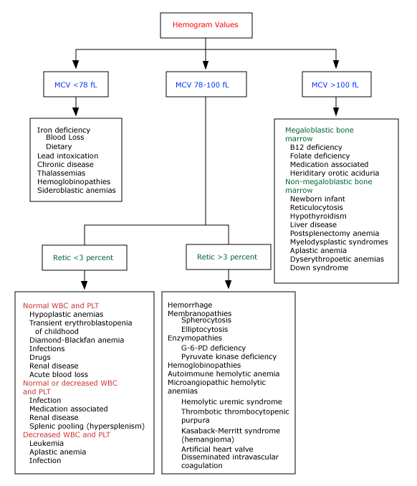

Iron Deficiency Anemia

 | Normal | Fe deficiency  No anemia | Fe deficiency Mild anemia | Fe deficiency  Severe anemia
Serum iron, µg/dL | 60 to 150 | 60 to 150 | <60 | <40
TIBC(transferrin), µg/dL | 300 to 360 | 300 to 390 | 350 to 400 | >410
Saturation (SI/TIBC), % | 20 to 50 | 30 | <20 | <10
Hemoglobin, g/dL | Normal | Normal | 9 to 12 | 6 to 7
Red cell morphology | Normal | Normal | Normal or slight hypochromia | Hypochromia and microcytosis
Serum ferritin, ng/mL | 40 to 200 | <40 | <30 | <10
Other tissue changes | None | None | None | Nail and epithelial changes

Other Common Anemias
Type | Clinical associations | Peripheral smear | Laboratory | Treatment | Response
Folate | Rough skin, glossitis | Macrocytic, normochromic;  hypersegmented PMNs | Nl, ↓ retic  ↓WBC, plt  ↓RBC folate | Folic acid 1mg/day | Retic: 48-72 hrs  Plt: few days  PMNs: 1-2 wks
B12 | Neuro defects | Macrocytic, normochromic;  hypersegmented PMNs | Nl, ↓ retic  ↓WBC, plt  ↓serum B12  Anti-intrinsic Ab | Vit B12 100µg/day x 1 week  Total of 2000µg by 6 weeks  Monthly for life if pernicious | Retic: 3-5 days  B12: 6-12 weeks
H. spherocytosis  Elliptocytosis | Hemolytic crisis with stress (preg) | Shistocytes, spherocytes | ↑RBC osm. Fragility  ↑ retic | Replacement transfusion  Splenectomy  Supportive tx with elliptocytosis | -
Autoimmune  Warm (IgG)  Cold (IgM) | W-malig, SLE, viral, drug  C-mycoplasma, EBV | Microcytes, polychromatopilia, poikilocytosis, normoblasts | ↑WBC  ↑Retic  + direct Coombs | W – Steroids (80%), splenectomy (60%), immunosuppression  C- avoid cold, immunosuppression, plasmapheresis, transfusion | variable
Enzymopathies  G6PD def | Drug or infection induced hemolysis | Shistocytes | ↑Bilirubin  ↑Retic | Discontinue medications (sulfa, nitrofurans, probenecid, anti-malarials, isoniazid), transfusion | variable
Aplastic  Hypoplastic | Autoimmune, drugs, infection | Normal morphology | Pancytopenia  ↑Retic | BMT (50-70%)  Supportive: transfusion, tx infection, androgens, splenectomy, IVIG, steroids | variable
PNH | Hemoglobinuria, thrombosis (atypical) | Shistocytes or normal | Pancytopenia | BMT  Steroids, androgens, transfusion, ecluzimab  Anticoagulation with thrombosis (heparin can precipitate hemolysis) | variable

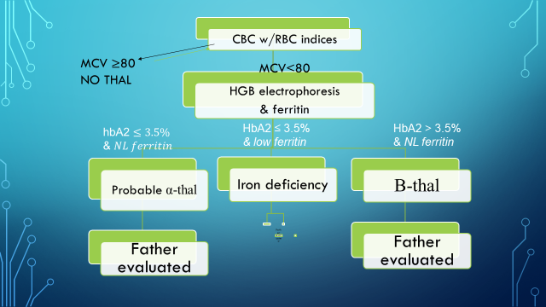
Check ferritin
Start iron supplement

