This is your ultrasound picture at __ weeks.

Insert your patient’s picture here.
Your cervix was found to be open on ultrasound, without symptoms of labor, infection or bleeding.
This is called Cervical Insufficiency.
The top of your cervix is about ___cm dilated with membranes coming out the length of your cervix and visible on speculum exam in your vagina. These are changes that should not occur until term and are very dangerous this early in pregnancy.
Observation at the hospital was recommended to assess for symptoms of preterm labor, infection or bleeding. If these occur, the only outcome is delivery now and any attempts otherwise would just increase risk to you without any benefit for you baby.
If no symptoms develop during your time of observation, management options include:
- Delivery – We can give you medicine to start your labor. You are in a very high risk situation: we may not be able to save your baby and you are at risk of complications if you stay pregnant.
- Watch and wait – We can let you go home or stay at the hospital, you can choose to limit your activities but we can’t say that this can help. Complications of “bedrest” can include blood clots. The most likely thing to happen would be that signs of labor, infection or bleeding develop within days to a couple weeks, before your baby would have a chance of survival if born. However, some women do stay pregnant much longer and do deliver a baby that may survive and be healthy.
- Cerclage – this is a minor vaginal surgery performed in the operating room with anesthesia. We try to replace the amniotic sac back in your uterus and close the top of the cervix with a suture. Any surgery carries risks of bleeding, infection, complications of anesthesia, pain and injury and it could cause your water to break, you to labor or damage your cervix for future pregnancies. However, complications are rare and it is usually very well tolerated. Patients may complain of change in discharge, a tugging or pulling sensation, but generally are comfortable. This is a picture of the best case scenario of how your cervix may look before and after surgery.

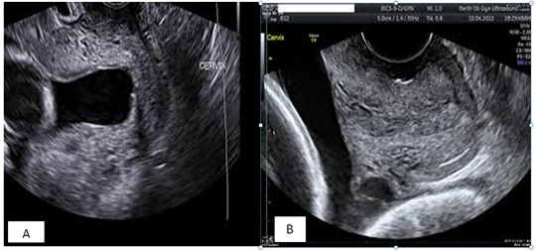

How do we think watch and wait compares to cerclage?
Limited, imperfect data suggests that cerclage increases the chance that you can stay pregnant significantly longer and have a baby that survives (71 vs. 43%). On average, you would stay pregnant 47 days (almost 7 weeks) longer with a cerclage, but the range of when patients deliver is quite broad (a few days to months with and without cerclage). When membranes protrude, the odds are even higher that you will deliver early and your baby won’t survive whether or not you have a cerclage, but appear to improve with cerclage. Complications of cervical insufficiency include breaking your water and developing an infection, but these risks do not appear increased with cerclage.
When can my baby survive?
Between 22 and 25 weeks, survival goes from 0% to >90%. Our NICU currently supports babies as young as 23 weeks. You are __ days from 23 weeks and __ days from 25 weeks. Some data suggests that if you stay pregnant >7 days, your odds of staying pregnant longer are much improved. Between 23 and 25 weeks, the rates of very severe complications of prematurity go from high to much lower. A healthy baby that survives with all efforts in place to improve outcomes at 23 weeks still has up to a 50% chance of having their ability to learn and develop significantly affected, but this drops to <33% at 25 weeks. The risk of not being able to walk, see, hear or live independently as an adult is small throughout this time. Beyond 25 weeks, outcomes continue to improve every week. Having a baby going through the challenges of being preterm can be very stressful for families and can significantly impact everyone going forward.
Medications to discuss:
- Tocolytics or medicine to stop labor (Indomethacin) – if we decide to place a cerclage, we start this medicine before and continue the day following your surgery to try to prevent contractions. This appears to be safe and helpful, especially if membranes protrude. Continuing this long term does not improve odds and carries risk.
- Antibiotics (Cefazolin) - if we decide to place a cerclage, we start give a dose of antibiotics to try to prevent infection. This appears to be safe and helpful, especially if membranes protrude. Continuing this long term does not improve odds and carries risk.
- Vaginal progesterone – Data suggests vaginal progesterone prolongs pregnancy when ultrasound shows a short cervix. It is reasonable to hope it could help someone with a dilated cervix, although data is limited. This is not done without the cerclage, as we will want to avoid touching the exposed membranes in your vagina.
There is no “right” choice in a situation as difficult as this – parents just make the best choice they can with consideration of what’s best for them and their family. We are here to help as are the NICU doctors who can talk to you about what to expect if you have a baby in the NICU and help make decisions about when interventions to improve outcomes, such as steroids for lung development and full resuscitation efforts, may be right for you and your baby.
If you have another pregnancy – we recommend early consult (<12 weeks) about possible measures to reduce the chances you have cervical insufficiency again. Possible interventions include earlier cerclage (prior to dilation), more frequent ultrasound of the cervix, and progesterone
KDD 5/26/21, modified 6/25/2021

